**BIG DATA-05**

**Checking whether Hadoop is installed**

>$ hadoop version

>$  start-all.sh

>$ jps

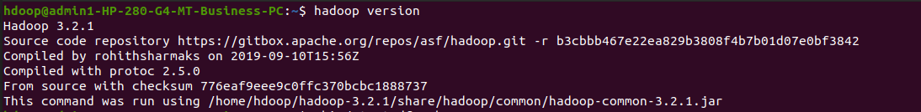

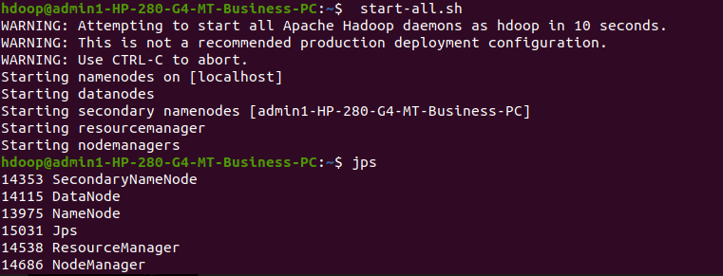

**Creating a directory named by my name**

>$ hadoop fs -mkdir soni



**Listing all the files and directories present**

>$ hadoop fs –ls



**Creating the empty file**

>$ hadoop fs -touchz s1.txt

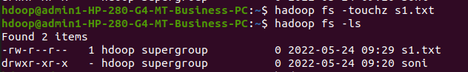

**Create a file in your local system to terminal and cat command**

> $ hadoop fs -copyFromLocal t.txt sp.txt

>$ hadoop fs -cat sp.txt



**Copy to local**

>$ hadoop fs -copyToLocal s1.txt s2.txt



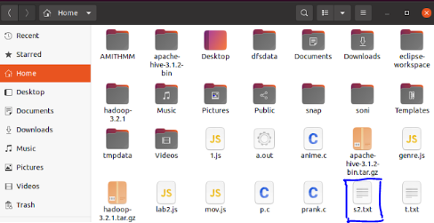

**Creating another directory by usn**

>$ hadoop fs -mkdir 1nt19is157

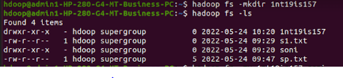

**Moving usn directory inside name directory**

>$ hadoop fs -mv 1nt19is157 soni

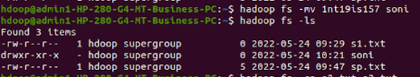

**Coping text from one file to another**

>$ hadoop fs -cp s1.txt s3.txt



**Size of the file and directory**

>$ hadoop fs –du

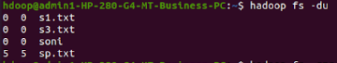

**Delete the files**

>$ hadoop fs -rmr s1.txt



**Total size of all files and directory**

>$ hadoop fs –dus



**Check time and date of particular file**

>$ hadoop fs -stat soni



**Moving files to directory**

>$ hadoop fs -mv s3.txt soni  
>$ hadoop fs -mv sp.txt soni



**Checking files under particular directory**

>$ hadoop fs -ls soni

